Minor Skilled

Tank Simulator

Term 3 & 4

Nils Meijer – 466301

Table of Contents

Product description 2

Project aspects I worked on: 2

Movement system 2

Camera controllers 3

Turret controller 4

Shoot system 4

Level design 4

AI behaviour tree 4

Damage registration system 8

Main menu 8

New input system 9

Polishing (adding “juice”, post-processing), fixing bugs 9

Progress comparisons 9

Evaluation 1 9

Evaluation 2 9

Evaluation 3 10

Final presentation 10

Workflow 10

Hour registration & planning 10

Quality Assurance 11

Future features & iterations 11

Appendices 12

Behaviour tree 12

References 12

# Product description

For the past 5 months, I have worked on a tank game. The original idea was to develop a simulator, meaning the experience would be close to reality and how tanks operate in real life. However, this eventually evolved into a less realistic tank “game”. Because of time constraints and difficulties in developing certain components of the project, I couldn’t fully complete the idea I had while brainstorming in the first few weeks. In hindsight, it would have been better to have brainstormed a slightly smaller, less ambitious project so that I would have more time to focus on research and properly test & implement the features.

In the final product, the game starts in an interactive main menu, with an option to quit the game or to proceed to the next scene.

## Project aspects I worked on:

* Movement system
* Camera controllers
* Turret controller
* Shoot system
* Level design
* AI behaviour tree
* Damage registration system
* Polishing (adding “juice”, post-processing), fixing bugs

### Movement system

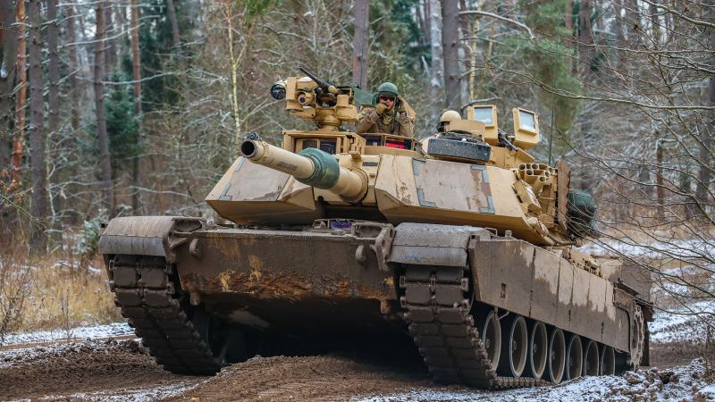

Figure 1 Tank tracks example (source: <https://edition.cnn.com/2023/03/21/politics/us-abram-tanks-accelerate-ukraine/index.html>)

I started out developing this system with the ambition to simulate real-life tank tracks as closely as possible. With a special type of colliders in Unity, which are WheelColliders, I would be able to create a tank track similar to the example in Figure 1. The wheels inside the track would respond to terrain changes, due to the suspension system. The only thing different would be that the WheelColliders would also be the contact point to the ground, rather than the track. In a real tank, the front and rear sprockets are ”powering” the track, which then makes contact with the ground. Due to that friction, the tank can move.

However, during a large part of the development, I struggled with making the WheelColliders behave the way I expected them to. The tank wasn’t even able to rotate properly. The way tanks handle rotation is to move the track opposite the tank is trying to move towards. Example: if the tank should rotate clockwise (so to the right), then the track on the left should be activated. Optionally, the track on the right can be reversely activated to create a stronger rotation force. This is how I tried it with the WheelCollider approach as well, but it didn’t work as expected. What happened was that it would either barely move at all, or the tank would need to travel a very large distance forward before having rotated the desired angle on the Y-axis.

Another reason why I struggled with implementing this WheelCollider approach was that, no matter how much research I did, I couldn’t wrap my head around the WheelCollider parameters that could be customized. Think of variables such as “Extrenum Slip” and “Extrenum Value”, and how they influenced eachother. I spent too much time trying to find a balance in these values.s

I decided to greatly simplify the whole movement component, and just resort to just adding forces to the Rigidbody of the tank.

### Camera controllers

As I was doing my research, I noticed many games had different (or multiple) camera views. In the beginning, I had 3 different views, which would be:

* **3rd person**

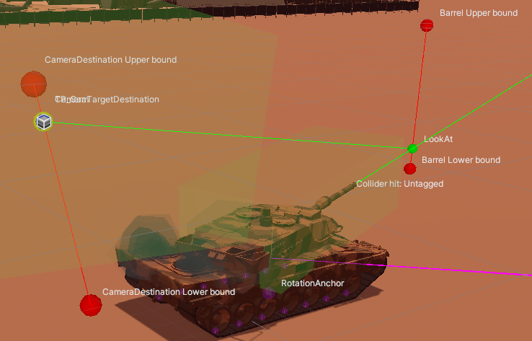

Figure 2 Camera gizmos

The camera follows the tank at a set distance, and can rotate a full 360° around the tank, as well as a limited range of motion on the x-axis. This will likely be the camera view that players use the most, to navigate around the scene and shoot targets that are relatively nearby. For this camera view, I did my best to visualize how the camera worked, by showing the boundaries for movement, and how it relates to the barrel

* **1st person**

A camera placed on any of the 4 positions marked in Figure 3, unable to move by itself. It was an attempt to mimic reality, but it wasn’t a gameplay element I had any use for. That’s why I decided to remove it, improving gameplay quality by decreasing complexity, at the cost of decreasing realism.

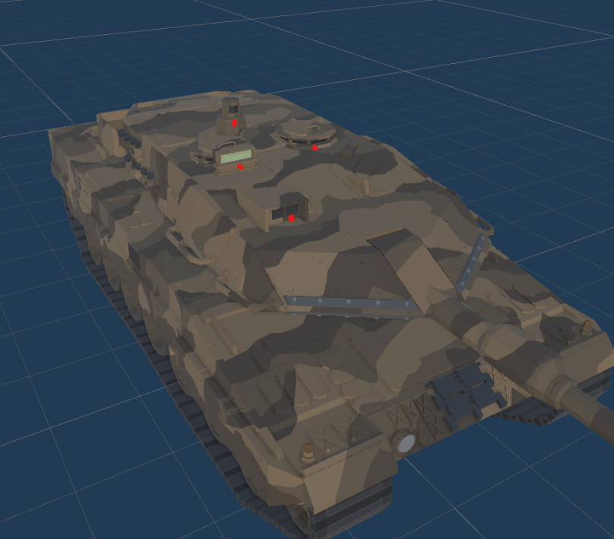

Figure 3, 1st person camera positions (red dots)

* **ADS**

A camera placed right above the barrel, which follows the y-rotation of the turret, and the x-rotation of the barrel. The player is able to zoom in using the right mouse button up to 5 times. This is done by decreasing the FOV, rather than physically moving the camera to a position in the distance. This would have introduced issues, such as moving into walls, being able to see behind walls and other edge cases that could not be solved which is why I changed it to FOV adjustments.

This camera view should be used to target enemies at larger distances, since the zooming ability helps with hitting those targets with high accuracy.

### Turret controller

A system to control the rotation of the turret and barrel of any tank this component is attached to. The player can do this by rotating the correct input axis (mouse, joystick). This will instantly rotate the “target rotation transform”. The turret uses this as a target to which it will rotate towards.

### Shoot system

Developing this component was another way to try and make the game a bit closer to reality. When using the proper input, a shell is spawned at and shot from the tip of the barrel.

During early/mid development of this feature, I spent a lot of time on a “ranging” system. During the research phase of my minor, I found that a lot of games had some kind of range finding way. For example, you would manually measure the distance to a point using UI called “mildots” (or the distance was measured automatically), and you would have to adjust the rotation of the barrel on the x-axis to account for shell drop, making sure that the shell would hit the target in the distance accurately.

Unfortunately, this didn’t work out. I decided to entirely scrap the range-finding feature, and to let the player rely on their own intuition. While playing, I found that it’s mostly a matter of finding the right camera view. If the selected camera view is ADS, then the player only has to use the correct zoom level.

### Level design

During programming, I sometimes need a break to replenish my energy for it. But to stay productive and spend my time on something useful for the project, I created a small level in which the player can move around in. It’s not finished by any means, but it’s good enough for a prototype level.

### AI behaviour tree

To blow more life into a game, in my opinion, it needs a presence other than the player itself. That’s why I decided to add AI agents. They are able to move around the world and make their decisions by the use of a behaviour tree. To design this behaviour tree and convert my thoughts into usable AI behaviour, I started with 4 “core nodes”, from which all other behaviour would derive. The 4 nodes are described next. You can see a visualization of every node (kind of like pseudocode, including what type of node it is. For a detailed explanation of what a behaviour tree is and how it works, refer to the “Behaviour tree” appendix.

* **Cover**

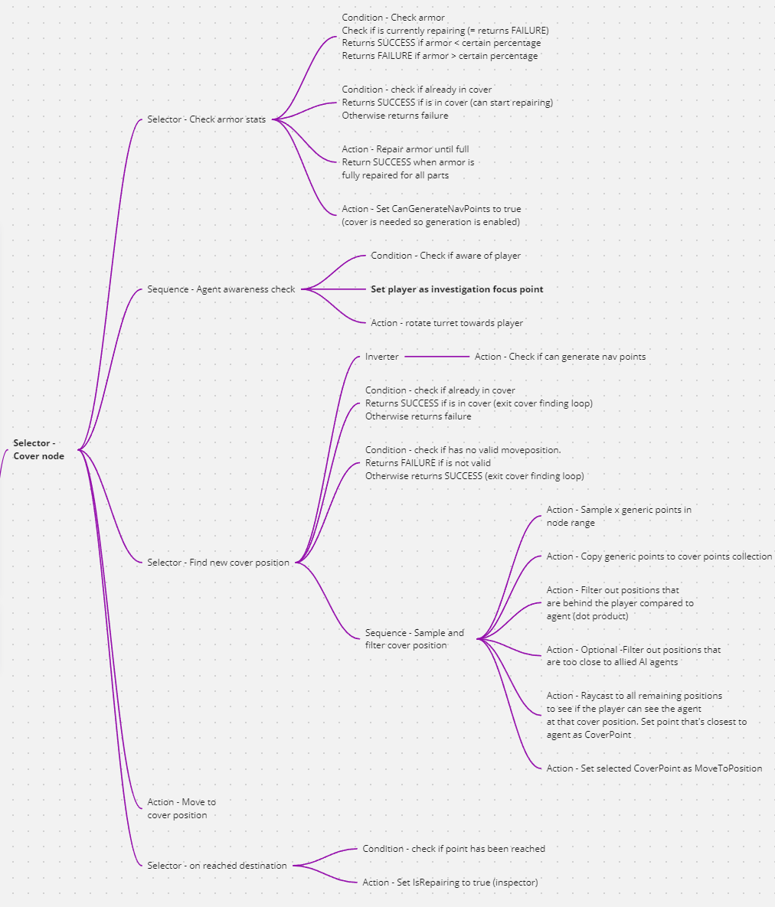

Figure Cover node visualization

* + If the armor stats of any tank part reaches a certain threshold, the AI will generate a set of points on the NavMesh. These points are all candidates for positions of cover. After generating, the AI will filter out the best options, and then choose the closest option. The AI will move to the chosen cover point.
* **Patrol**
  + The AI generates a set of points on the NavMesh. This time, these positions are possible patrol points. Again, the AI will filter out the best patrol points, and then moves to the chosen patrol point.

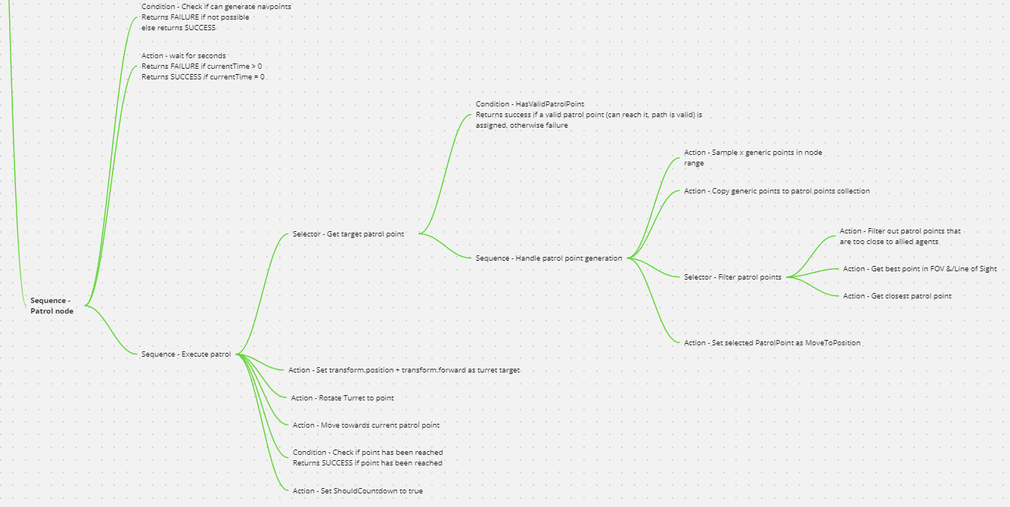

Figure Patrol node visualization

* **Shoot**
  + The AI will check if the player is in range, inside the Field of View and if there is a clear Line of Sight. If all conditions are met, the AI will check if it meets the requirements to fire a shell towards the player, and proceeds to do so if possible.

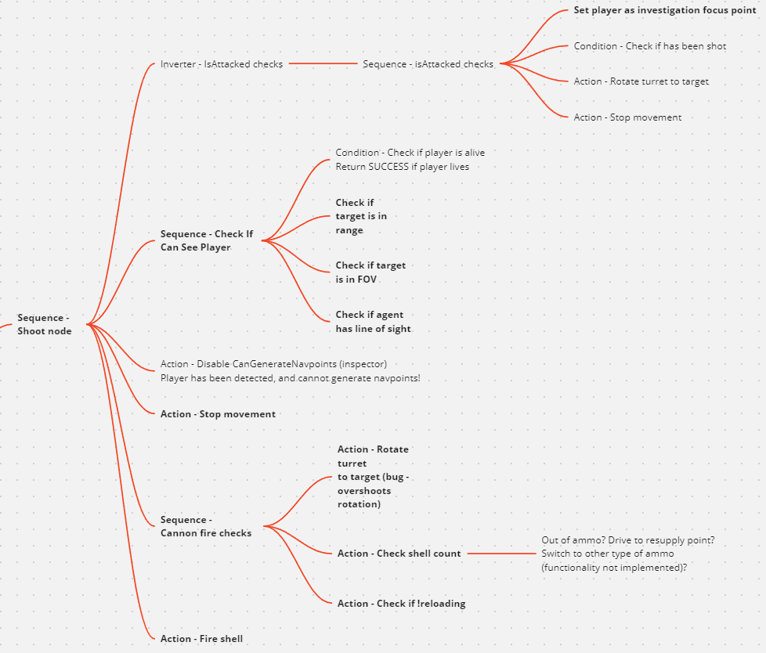

Figure 7 Shoot node visualization

* **Investigate**
  + The player will check if the player if the player meets all the requirements from the “shoot” node, but with higher values (more range, wider FOV). When these nodes return success, the AI will start to move towards the player. Eventually, the player will get into shooting range and therefore the tree will switch to the “shoot” branch.

Figure 8 Investigate node visualization

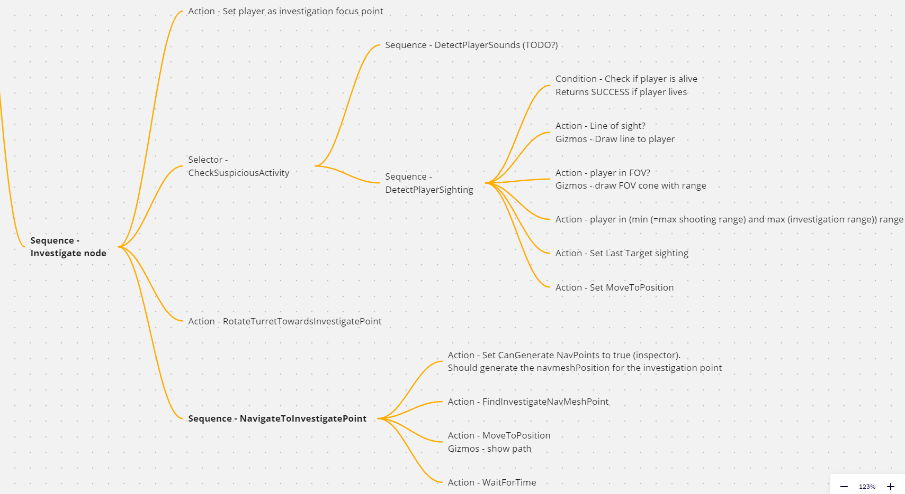

Sometimes it would be rather difficult to debug what the cause of a certain problem was because I don’t have a visual node editor (something to develop in the future, so it’s possible to release this behaviour tree code as a plugin). Designing the tree with the website <https://miro.com/> made it more doable to get an understanding of how I would imagine the final behaviour. Another way to understand why the behaviour didn’t work as expected and desired, was by logging the “nodeState” of all (or just the selected) nodes, as can be seen in “Figure 8 Behaviour tree console logging“.

The advantage of a behaviour tree compared to a finite state

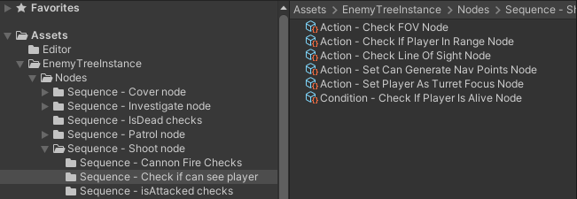

Figure 11 Behaviour tree hierarchy

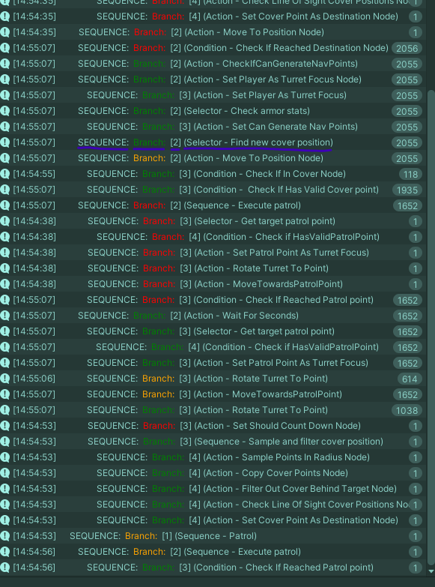

Figure 8 Behaviour tree console logging

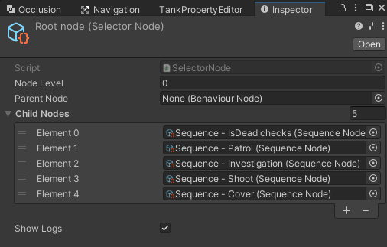

Figure Behaviour tree inspector

### 

### Damage registration system

In a tank combat game, the tanks obviously need to be able to be destroyed. That’s why I spent a few weeks on developing a damage registration/health & armor system, as well as a way to repair that damage.

With this component, the shells that hit the tank get registered and damage is applied to the part it hit. Once a part (can be the left track, right track, hull or the turret) has been destroyed (no armor and no health left), the tank explodes & therefore has been defeated. If a part has not been completely destroyed but its armor has been depleted, the armor can be regenerated. The same cannot be said for the health bar, as that’s considered permanent damage.

The player can inspect their tank by pressing the corresponding input. The camera view will then switch to an “inspection view”, where the properties for each tank can be seen, and repaired if necessary. The camera can rotate around the tank in a full 360° circle, as well as zoom in to a certain depth.

This exact same component is being reused for the enemy AI, as I have made it as generic as possible. This way, I didn’t have to write the same logic twice in a slightly different manner. For hostile tank inspection, I did make a “hostile tank inspection view”.

### Main menu

Every game of course needs a main menu to start the gameplay. I’ve always been a fan of these interactive menus. It makes the game feel more alive and adds to the atmosphere. For example, in my menu, I added a tank of which the barrel follows the position of the mouse. When I click any of the buttons, it shoots a shell, playing an explosion particle system. When loading the main menu scene, the gameplay scene is loaded asynchronously in the background. This prevents any loading screen or hickups/lag when clicking “play”.

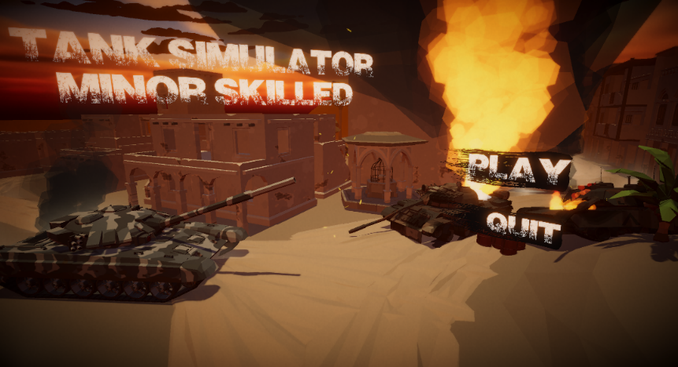

Figure 11 My main menu

### New input system

At first, I was still using the input handling system I was used to. However, during one of the Guided Work meetings and one of my QA sessions, I received the feedback I might want to check out the new input system, designed with several input devices in mind. This way, it’s easier to add new ways of input later on in development. It took some time and getting used to the new approach of handling input, but I got at least the basics of how it works down. Overall, it’s more robust and efficient.

### Polishing (adding “juice”, post-processing), fixing bugs

Added FOV animated change (higher FOV when driving, normal FOV when stationary) to 3rd person camera.

# Progress comparisons

|  |  |  |  |
| --- | --- | --- | --- |
| Evaluation 1 | Evaluation 2 | Evaluation 3 | Final presentation |
| [Tank simulator demo - 16-03-23](https://www.youtube.com/embed/MZfnDB9sM3g?feature=oembed) | [Tank simulator demo - 20-04-2023](https://www.youtube.com/embed/_fXscsjpiMA?feature=oembed) | [Tank sim demo 30-05-2023](https://www.youtube.com/embed/HcJr45zD4Rw?feature=oembed) |  |

### Evaluation 1

During the first 4/5 weeks, I brainstormed and expanded on several concepts, from which I eventually chose the tank simulator. After doing research, I started working on a very rough prototype. I made a simple camera controller with 3 (later to be reduced to 2) camera views. The turret can be controlled by moving the mouse, and the barrel by scrolling the mouse wheel.

The move component & physics values of every tank in the scene can be edited through the custom editor. I also worked on a mechanic that allowed the firing of tank shells, but it was still very much in the early stages and the shells didn’t have any effect on the surface they impacted with.

### Evaluation 2

At this point, I had designed a small level in which the player was able to move around. I also enormously improved the aiming system, as well as the turret control component. Rather than instantly rotating the turret, the camera now looks at an invisible “target look at”, which rotates instantly. That’s also the target the turret is rotating towards. This way feels and looks better than rotating the turret at an instant.

In this period, I worked on a range finding system which ended up getting scrapped. It didn’t work out the way I planned so I decided to not waste any more time on trying to fix it.

Another main aspect I spent a lot of time on during these weeks was a damage registration component system. Refer to “Damage registration system” for a detailed explanation on this component.

To organize all these components and streamline the logic to a centralized place, I converted the existing (messy) codebase into a Finite State Machine. This allowed me to organize logic much better into classes that only get activated if certain conditions are met.

### Evaluation 3

These weeks, I almost exclusively worked on an AI behaviour tree. I combined the behaviour tree with the previously mentioned Finite State Machine, so that I could reuse all of the component logic I made for the player. For example, a Shoot Component is attached to both the player and the agent. The agent can access that component through the state returned by its state switcher.

### Final presentation

In the last part of my minor, I spent almost all of my time on polishing, fixing bugs and adding missing functionality. And of course, writing this report took some time as well. I did my best on designing comprehensible flowcharts/UML diagrams, so it’s easier for “outsiders” to get an understanding of how my project is built, and how the classes communicate with eachother.

# Workflow

I did all my hour planning, brainstorming, functionality planning and documenting in a software called “Obsidian”. I hadn’t used it in a (for me) large scale project before, so I wanted to see how it would affect my workflow for such a long-term project. There are some things that can be improved, but overall I liked working with it.

During the first few weeks, I would go to school when I knew some of my friends were there as well, so I’d force myself to get out of the house more and make sure I’d get some social interaction. However, apparently it’s required to “reserve” the monitors/PCs in the XR lab and I’d often not know if I would be at school. There were a few occasions I managed to get a 2nd screen to work on, but often I just had to work on my small 17” laptop screen. So after probably the 1st evaluation, I really only came to school for the Guided Work meetings and just stayed at home the rest of the week so I could work more comfortably at my own PC. I’d often sit in a Discord voice channel with some friends to get some social interaction.

Every day, I would work from ~8.30-9.00 to around 16.00 so that equates to ~35 hours (5 * 7) a week. I usually keep working during lunch. In the last quartile however, I struggled with keeping up motivation and hours (together with combining working on redos, going to the gym, working at my sidejob, keeping my place clean and seeing my parents during the weekends) so those hours are more in the range of 30-32 hours.

# Hour registration & planning

I tracked my hours using the software “Toggl Track”. The program is basically just a stopwatch, which remembers the time entries so it’s easy to see how much you worked every day and on what aspects of the project. In the desk view, it’s possible to export a visualization of this data, which is what I used during the evaluation presentations and the final presentation to justify my hour registration.

Around every evaluation, I would look at my hour planning and check where it needed readjusting. During my internship, I also had to estimate how many hours I would need for a certain task, and review that planning after completion (and also update it during development, of course). That experience helped with doing the same for this minor. But as with all things, my hour estimation skills can still be improved (and will happen as I grow as a programmer).

# Quality Assurance

Before any QA meetings, I was planning on doing a QA with professional programmer in the game development industry. For the first meeting, I messaged and emailed several studios working on a tank-related game. I also made posts in several Reddit game development groups. Unfortunately, I got 0 responses (and in the reddit groups, I even got downvoted). I ended up asking a former colleague from my internship at Total Reality as the first Quality Assurer. He replaced the previous lead developer (who was my internship coach), but left the company again after about 2 months. For the 2nd, 3rd and 4th Quality Assurance meetings, I asked Hans Wichman and Yvens Serpa.

I also made a lot of use of ChatGPT during development, although it doesn’t count as QA in my opinion. Rather as a way to help me get out of being stuck with a certain problem.

# Future features & iterations

* Tank customization
  + Originally a feature I was planning to develop for this prototype. I wanted the player to have more control of the tank they were playing with. Both in a gameplay aspect and a visual, eye-appealing aspect. For example, purchasing a light source that can be attached to the tank to make it easier to navigate through a level when it’s dark. This would be a gameplay customization. A visual customization would be buying a different skin for the tank (another camouflage colour).
* Behaviour tree node editor
  + An upgrade for the current behaviour tree designing process. It will be easier to design and debug behaviours. The tree itself would be visualized, rather than
* More sound effects
* Placing landmines
  + This would improve the combat dynamics, as both the player and the AI can decide to place landmines in a strategic location, which enables more complex combat scenarios.
* A dynamic day-night cycle.
* Other types of ammo
  + Having several types of ammo (which was the plan at first but has been scrapped due to time constraints) would make the combat more dynamic, forcing the player to choose about the way they approach a combat scenario. For example, if you inspect an enemy tank and see it has exceptionally high armor properties but relatively low health properties, you would want to choose an armor-piercing shell round so it’s a way around the heavy armor.
* More levels
  + Combined with the quest system, this would make the game more immersive, because there could be a story-telling aspect if there were several levels.
* Quest system
  + A feature that allows for an actual “purpose” in the game, rather than just driving around and killing enemies.

# Appendices

### Behaviour tree

A way to design AI behaviour, using a tree-like structure. The tree is built from a set of different node types. There is one “root node”, from which all other nodes are run. In my implementation, there are 3 different node types being used.

* Sequence node: all child nodes have to return SUCCESS, otherwise if any child returns FAILURE, the node fails and stops the branch depending on the setup of the parent branch.
* Selector node: if any child node returns SUCCESS

# References